Your Project Title
Your project subtitle
Course Number and Section
Student Name and ID
Hyunhee Kim 300372531
Date

Table of Contents
1 Introduction 2
2 Proposed Research Project 2
3 Project Planning and Timeline 2
4 Implemented Feature A (you are free to modify this title text) 2
4.1 Introduction/Overview (please change the title as necessary) 2
4.2 Details of Implementation 1(please change to reflect your implemented feature) 2
4.3 Details of Implementation 2 (please change to reflect your implemented feature) 2
5 Lessons Learned and Future Work 3
6 Concluding Remarks 3
7 Appendix 3
7.1 Appendix A: Installation Guide 3
7.2 Appendix B: User Guide 3
7.3 Appendix C: Dataset and API Used (You May Change the Title as Necessary) 3
7.4 Appendix D: Hardware, Software, Cloud, Architecture, etc., (You May Change the Title as Necessary) 3
7.5 Appendix E: Code Explanation (You May Change the Title as Necessary) 3

Introduction
This is the introduction part of your proposal.

Proposed Research Project
This this the proposed research project of your proposal.

Project Planning and Timeline
This this the proposed research project timeline.

Implemented Feature A (you are free to modify this title text)
This is where you need to describe all the work, approach and implementation you have done in your project. Try as much as you can to align the part here with the proposal part in the previous sections.
This template provided three subsections of this part of implementation. You are free to add or reduce the number of subsections to match whatever work you have done. The text of the Section and Sub-section should be modified to match with your work.

Introduction/Overview (please change the title as necessary)
You may want to provide some introduction or overview on this part of the documentation. In here, you may connect the implementation details with your proposed research objectives and timeline, research that has been done, changes in directions that was implemented, etc.
The personality profiling feature is one of the core components of our Career Path Recommendation System. This feature analyzes a user’s personality traits through a customized OCEAN-based questionnaire and uses machine learning models to determine the user’s personality type. The initial project proposal aimed to build a personality-driven recommendation pipeline by combining user characteristics, job requirements, and skill gaps. Although the final implementation did not fully achieve a personality-to-job matching system, we successfully developed a complete pipeline that evaluates user personality traits, classifies the user into one of five personality clusters, and generates a structured personality report.
During the proposal stage, we planned to adopt the original Big Five assessment format. However, after conducting early testing and receiving feedback during the midterm presentation, we revised the interaction design to use 25 selected questions with a 0–5 integer scale, which more closely reflects standard personality assessments. We also refined our personality descriptions to provide clearer explanations so users can better understand the results.
This feature serves as a foundational element for future enhancements, where personality types could be aligned with job categories, required competencies, and course suggestions in a full recommendation pipeline.

Details of Implementation 1- k-means personality clustering
This is where you describe your solution, and implementation of your features. Provide illustrations, diagram, architecture, etc., of the implemented feature as necessary. Provide screenshots of your code and explanations as necessary.
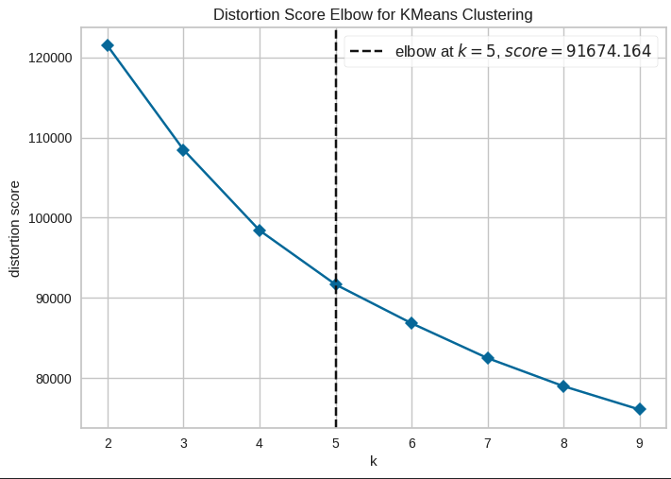
[Insert Figure 4.2.1: K-Means elbow plot]
K-Means elbow plot for determining the optimal number of clusters
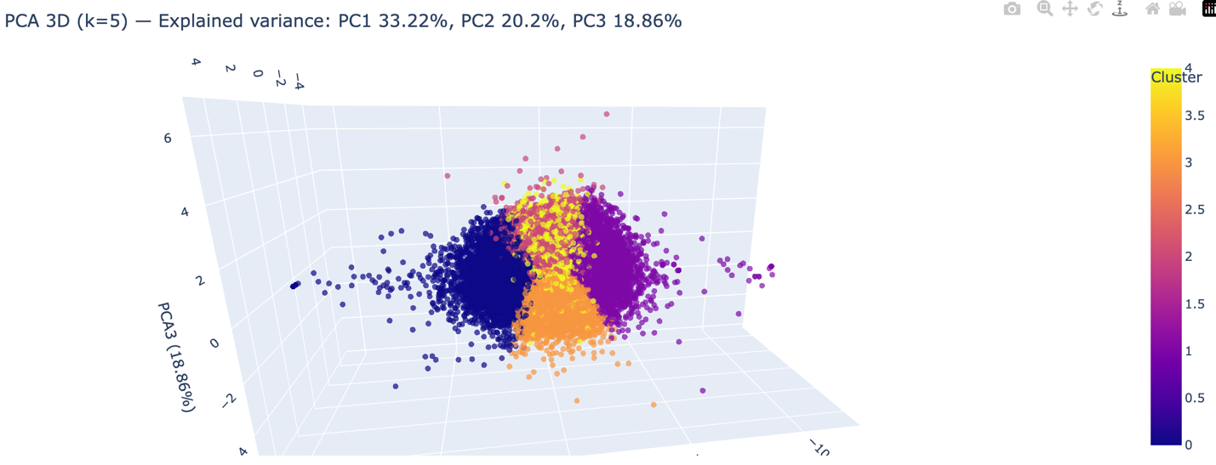
[Insert Figure 4.2.2: K-Means Cluster visualization]
3D PCA visualization of the five K-Means personality clusters.

The first stage of the personality feature involved clustering personality scores using K-Means, an unsupervised machine learning algorithm. We collected and analyzed the dataset to identify the optimal number of clusters using the Elbow Method and silhouette evaluation, and after multiple experiments, we selected K = 5, which produced clearly separable and interpretable clusters. During data preprocessing, we scaled all 25 personality question responses using the StandardScaler to ensure consistent variance across features, converted all inputs into an integer-based 0–5 format to match the structure of the personality test, and applied reverse-scoring to negatively keyed items so that all questions aligned directionally. Additionally, normalization procedures were applied to maintain equal weight across the five OCEAN dimensions.
Once preprocessing was complete, the K-Means model successfully grouped users into five distinct personality categories. Rather than presenting users with raw numeric cluster labels, we created meaningful and readable category names, such as the Balanced Collaborator and the Reserved Analyzer. For each of these clusters, we wrote extended personality descriptions to help users better understand their behavioral tendencies, strengths, and areas for improvement.
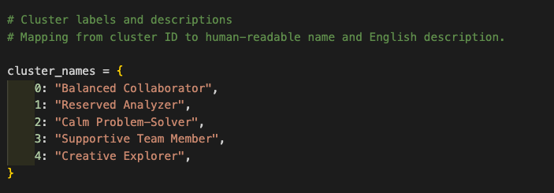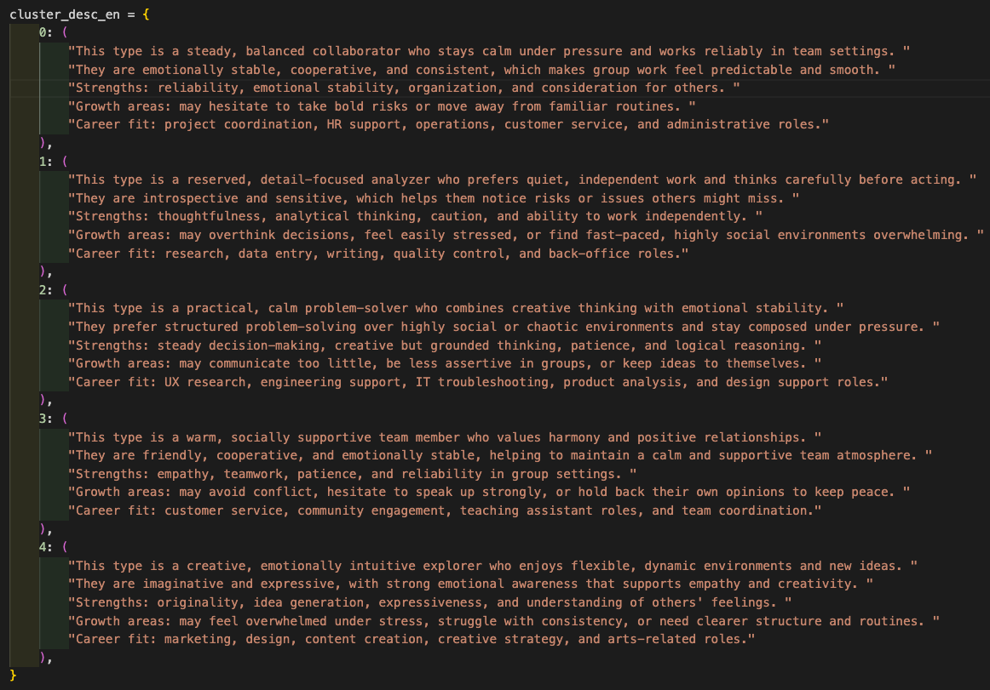
[Insert Figure 4.2.4: Example Cluster Description Screenshot]
These descriptions include strengths, tendencies, communication style, and potential areas for growth.

Details of Implementation 2 – randomforest classification
This is where you describe your solution, and implementation of your features. Provide illustrations, diagram, architecture, etc., of the implemented feature as necessary. Provide screenshots of your code and explanations as necessary.
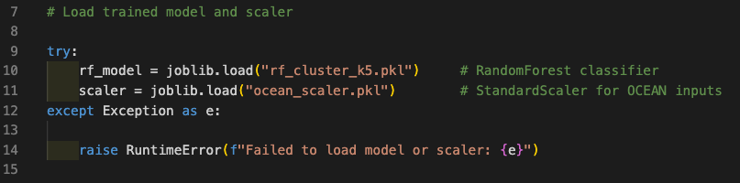
[Insert Figure 4.3.1: personality_model.py Screenshot]
Code snippet from model.py showing how the Random Forest model and scaler are loaded.
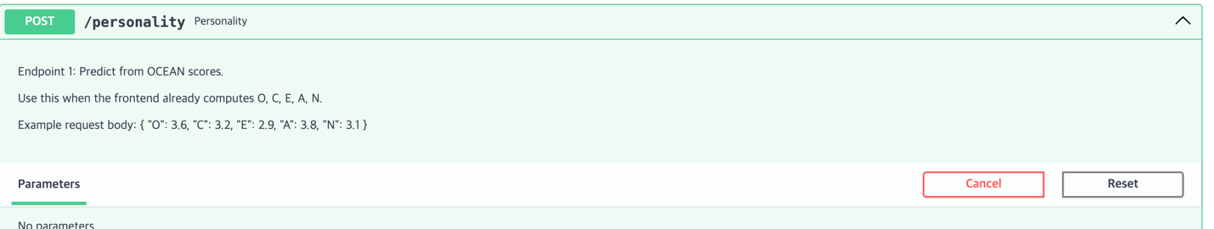
[Insert Figure 4.3.2: API endpoint Definition in Swagger UI]
This screenshot shows the /personality POST endpoint documented in Swagger UI. It outlines the endpoint description, expected JSON input format, and example request body. This confirms that the FastAPI backend exposes a well-defined interface for receiving OCEAN personality scores.
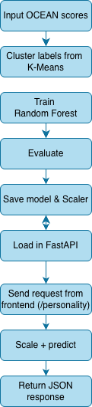
[Insert Figure 4.3.3: Random Forest Pipeline Diagram]
This diagram illustrates how the Random Forest classifier is trained and deployed. OCEAN scores are combined with cluster labels generated by K-Means to train the model. After evaluation, the trained model and scaler are saved and loaded by the FastAPI backend. When the frontend sends new OCEAN scores to the /personality endpoint, the backend scales the input, predicts the cluster, and returns the cluster ID, name, description, and probability distribution as a JSON response.
To provide real-time predictions on the website, we trained a Random Forest classifier using the cluster labels generated from the K-Means model. This transformed the unsupervised clustering into a deployable supervised prediction model. The model, along with the scaler, was saved as .pkl files for integration.
We implemented the backend using FastAPI, creating an endpoint /predict that:
- Receives the 25 trait responses from the frontend
- Scales the input using the saved StandardScaler
- Predicts the user's personality cluster
- Returns the cluster label and the full personality description in JSON format
During the midterm presentation, the frontend-backend connection was partially functional, but the final prediction output did not display properly. After refining the API logic, CORS settings, and input validation, the final implementation successfully returns the user’s personality type on the website.
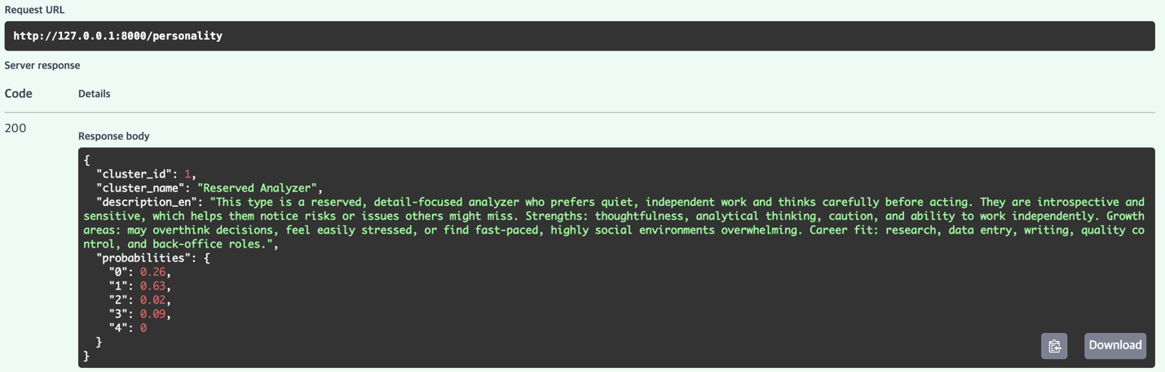
[Insert Figure 4.3.4: Swagger UI “Try Out” Example Output]
This figure shows the actual output returned by the Random Forest classifier. The response includes the predicted personality cluster, human-readable personality description, and probability distribution across all five clusters.
This completed the functional pipeline from questionnaire -> ML model -> API -> real-time website result.

Lessons Learned and Future Work
5.1 Lessons Learned from Technical Development
Provide the reflections and important lessons you have learned from your research project, how it is related with your coursework (if any), your future career aspirations and future work that you may carry forward from your applied research work.
Throughout this project, we significantly expanded our understanding of data acquisition, modeling, and system integration. We learned how to search for appropriate datasets, use web scraping, and evaluate dataset quality before modeling. Initially, we attempted to merge job and course datasets from Kaggle to build a combined recommendation system. However, during preprocessing, we encountered substantial data loss, which forced us to rethink our data strategy. This experience taught us that merging datasets is not always necessary and that modeling can often be done more effectively by treating datasets independently.
Working with large and real-time datasets also highlighted the importance of managing dataset size and sampling. Training machine learning models on large files resulted in long processing times, so we learned how to extract balanced and representative samples for efficient modeling.
We also learned how to save machine learning models using pickle, load them through FastAPI, and deploy them as real-time components of a web application. Before this project, most of our data analytics coursework focused on modeling inside Jupyter notebooks. This project taught us how to transform models into functional, usable components integrated into a real website.
5.2 Lessons Learned from System Integration and Fast API
This project was our first experience implementing both the frontend and backend components of a data-driven application, and FastAPI served as our primary tool for connecting the personality model to the website. Through this implementation process, we learned how to structure API endpoints effectively so that the system could accept and process user input in a consistent manner. We also learned how to validate and handle incoming JSON data to ensure that the model receives the correct format and values, as well as how to configure CORS policies to enable seamless communication between the frontend and backend without triggering access errors. In addition, we became familiar with testing API endpoints through Swagger’s built-in interface, which allowed us to quickly experiment with input values and check whether the prediction pipeline was functioning correctly. Finally, we gained experience returning prediction results in clear and structured formats that could be easily interpreted by the frontend.
These combined skills helped us understand the real-world workflow of deploying machine learning models rather than simply training them in isolation. Concepts that previously felt disconnected, such as frontend frameworks, backend logic, and machine learning modeling, came together cohesively through FastAPI, giving us a much deeper and more practical understanding of how data science and software engineering interact in real applications.
5.3 Personal Growth, Teamwork, and Career-Relevant Learning
This project also strengthened our teamwork and communication skills. We collaborated across different roles, frontend, backend, modeling, and helped each other fill knowledge gaps. This experience will be valuable in future careers where cross-functional collaboration is essential.
We also gained confidence in applying what we learned in Douglas College’s CSIS courses. Concepts that once felt abstract became meaningful when we implemented them into a real system. This project broadened our understanding of how data analysis, software engineering, and machine learning intersect in modern applications.
5.4 Future Work
There are several enhancements we hope to implement in the future to expand the capabilities of the system. One of our primary goals is to develop a personality-to-job compatibility scoring mechanism that can evaluate how well a user’s traits align with specific roles. We also intend to expand the job and course datasets so that the recommendation results become more comprehensive and reliable. Another area for improvement is feature selection, where reducing the number of questions while maintaining predictive accuracy would make the assessment more efficient and user-friendly. Beyond this, we aim to build a full recommendation pipeline that connects job suggestions with required skills and relevant courses. Future development could also involve deploying the system on cloud platforms such as AWS or Azure to improve scalability and reliability, and enhancing the UI/UX for clearer and more engaging result visualization. With additional data, refinement, and technical development, this system has the potential to evolve into a fully operational platform that meaningfully supports students and new graduates in making informed and confident career decisions.

Concluding Remarks
You put your concluding remarks of your project here. You may also acknowledge your colleagues, Douglas College and whoever has helped you in your project.
Our project began with a shared desire to help students and new graduates who struggle with finding the right career path. As we approached graduation ourselves, we felt the same uncertainty and pressure, which inspired us to create a system that uses data to support people during this important stage of life.
Although the current version is limited by dataset size and scope, it demonstrates that data can reveal meaningful insights about personal strengths and areas for improvement. We believe that everyone has a career path that suits their personality and abilities, even if it is not immediately obvious. It is our hope that future versions of this project will serve as a valuable resource for job seekers and help them save time, gain confidence, and discover new opportunities.
This project was also a meaningful academic experience. We are grateful for the opportunity to apply the knowledge gained from our courses into a real project. We would like to express our sincere thanks to Professor Bambang Sarif for his guidance, feedback, and encouragement throughout the project, as well as to the instructors at Douglas College who taught the CSIS courses that supported our learning.
Finally, I especially thank our team leader, Leshan, for guiding the team, supporting us, and helping turn our ideas into a functional system. This project was a collaborative accomplishment, and we appreciate everyone who contributed to its success.

Appendix
Please make some additional notes if you think it will help people understand your work. This include information the installation guide, the user guide and anything about the system/software you are using (that the company allow you to share, if you work with a company), datasheet (explanation of) of hardware/components you used (if any), etc.

Appendix A: Installation Guide

Appendix B: User Guide

Appendix C: Dataset and API Used (You May Change the Title as Necessary)

Dataset Used
- Job Dataset
  - Source: Kaggle
  - Content: Job titles, required skills, soft skills, experience level
  - Purpose: Future extension for job, personality matching and skill gap analysis
- Course Dataset
  - Source: Kaggle
  - Content: Course title, description, skills taught
  - Purpose: Course recommendation pipeline
- Personality Dataset
  - Source: Custom dataset created by the team, based on items adapted from the International Personality Item Pool (IPIP) Big Five personality assessment
  - Content: 25 personality questions (0-5 scale), OCEAN feature aggregation
  - Purpose: The dataset was used to train the K-Means clustering model for personality segmentation and to generate cluster labels for training the Random Forest classification model

API Used (screenshots only recommend)

Appendix D: Hardware, Software, Cloud, Architecture, etc., (You May Change the Title as Necessary)

Appendix E: Code Explanation (You May Change the Title as Necessary)
- My code explanation. Rough idea of code, take screen shots

Loading Machine Learning Models (personality_model.py)
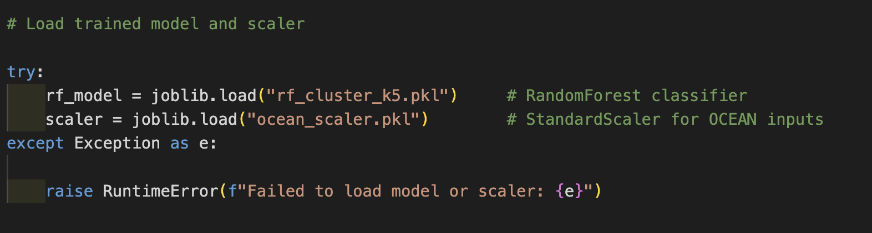
The personality_model.py file is responsible for loading the trained RandomForest classifier and the StandardScaler. When the application starts, the file attempts to load the pickled model (rf_cluster_k5.pkl) and scaler (ocean_scaler.pkl). It also defines cluster names and descriptions that map the numeric cluster output to human-readable categories. This file provides a helper function that formats the prediction result before returning it to the API.

Personality Prediction Endpoint (main.py)
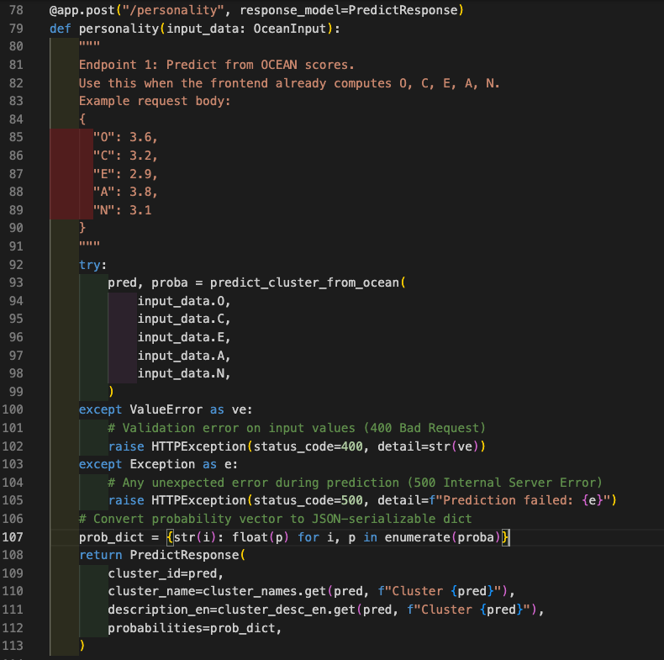
The /personality endpoint receives five OCEAN scores from the frontend as JSON. Once the data is validated through Pydantic (OceanInput), the scores are scaled using the loaded StandardScaler, and the RandomForest model predicts the personality cluster. The endpoint returns the cluster ID, cluster label, description, and probability distribution of all five clusters.
This endpoint is used by the frontend personality UI to show users their personality type.

